Quarter Hat Days!!!
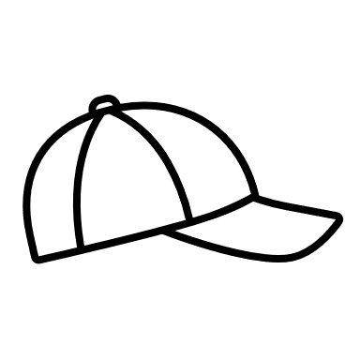

Bring a quarter every Friday and you can show your style by wearing your favorite hat!
Proceeds go to benefit Relay for Life!

WANT TO SHOW OFF YOUR SCHOOL SPIRIT?

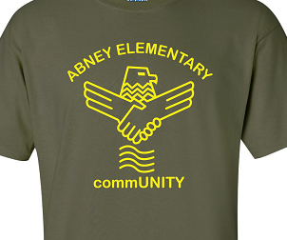
ABNEY COMMUNITY SHIRTS ARE NOW AVAILABLE FOR PURCHASE ON REVTRAK
$12 EACH

DOES YOUR LITTLE EAGLE WANT TO SHOW THEIR SCHOOL SPIRIT?
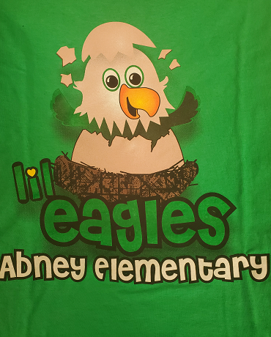
GRAB A LIL’EAGLES SHIRT! AVAILABLE ON REVTRAK FOR $12

